Synergy and Air Products Summary
July 2017
Hi everyone,
First of all, thank you very much for attending our workshops over the last few months. The purpose of these workshops was to give you an insight of what better technique should generally look like, different types of training you can implement and the importance of strength training. Below is a brief summary on what we have covered so far.
Technique
Technique has been seen to be a key determiner of efficient running, but also comes with time. There are some key points below that you should loosely try to follow when you run but do not feel like you should have to run in an exact manner straight away. Speed sessions, strides and hill sessions are ideal times to practice these key points.
- Tall posture (not too flexed from trunk)
• Relaxed shoulders, efficient backwards arm swing
• Foot strike happens close to centre of mass (COM)
• Knee slightly flexed at initial contact with vertical shin
• Minimal lateral movement - no 'medial collapse'
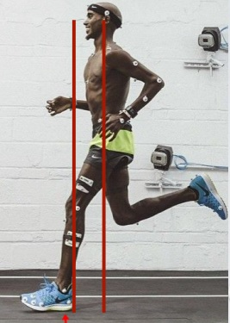

The image on the left shows Mo Farah generally following these rules. But is he perfect? He still has an over-stride here, despite being one of the world’s best runners.
We also need to consider that we will often self-optimise. As a general rule of thumb I would say to follow the rules above, try to keep a high step rate (cadence) - especially on slower runs - and practice your heel lift/hip and knee drive on your faster runs. Strength training will also help (see Training Plans.

Training Structure
Training for longer runs should generally follow an 80%/20% percent rule. Meaning 80% of your running is at a low intensity and 20% is made up of high intensity work.
The running physio (http://www.running-physio.com) put together this great image that displays this well:
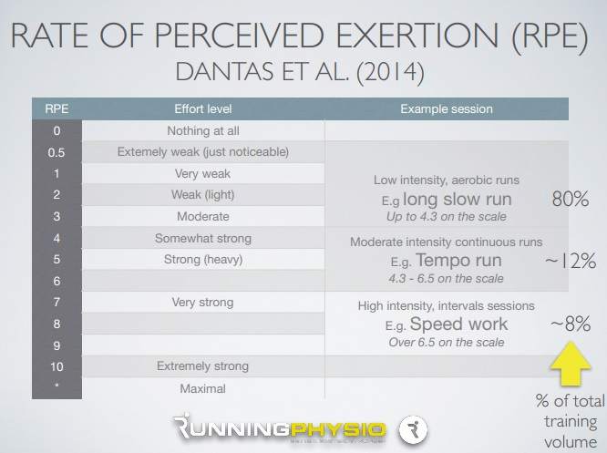

A basic training structure could look like:
- 3 runs per week
  - Long slow run - easy, comfortable can chat
  - Tempo run - medium, 'comfortably hard'
  - Speed session - hard, strong effort
Build up for three weeks and back off a little for one week.
Common Training errors include:
- Increasing running volume, intensity or frequency too quickly (the recommendation is no more than 10% increase per week)
- Inappropriate mix of low and high intensity sessions
- 'Bunching' of sessions e.g. 'weekend warriors'!
- Inadequate rest
- Boom and bust

Strength Training
Strength training is very important when we begin to run and also to improve running economy. It is worth remembering that our cardiovascular fitness improves very quickly but our muscles, tendons, bones and ligaments take a little longer to adapt. Strength training helps to promote this.
Strength training on average has a 4.6% ⬆ in running economy (range 3 - 8.1%). A 3% improvement in performance equals 27 sec improvement in a 15 minute 3km time.
You should strength train on rest days and/or easy days. Try to avoid bunching strength and speed sessions together.
A general rule of thumb to follow would be:
- 3 to 4 sets of 8 to 12 reps
- Working to fatigue within those reps
- 2 to 3 minutes rest between sets
The above is a brief summary of the key points. Videos of some of the sessions are also on the Articles and Videos page of our website. Below are links to sites you could follow for further info:
- www.running-physio.com
- http://www.kinetic-revolution.com/
- http://www.sportinjurymatt.co.uk/
- http://strengthrunning.com/
- https://chrisjohnsonpt.com/
Also, it would be great if you can follow us on our Facebook pages:
https://en-gb.facebook.com/synergyphysio1/
https://en-gb.facebook.com/runschoolwoking/
We regularly work with injured runners getting themselves back on track and we equally work with runners on an individual level improving their technique, strength, mobility and training habits.
Thanks again,
Synergy Running and Movement Centre & Synergy Physiotherapy

